NT21 Assignment 2

Linux, Numeric Systems, Static IP address/subnets configuration, ARP

Task 1: Do Linux Tutorial

Go to <http://www.ee.surrey.ac.uk/Teaching/Unix/unix2.html> and do the 2nd basic Unix tutorial.

2.1

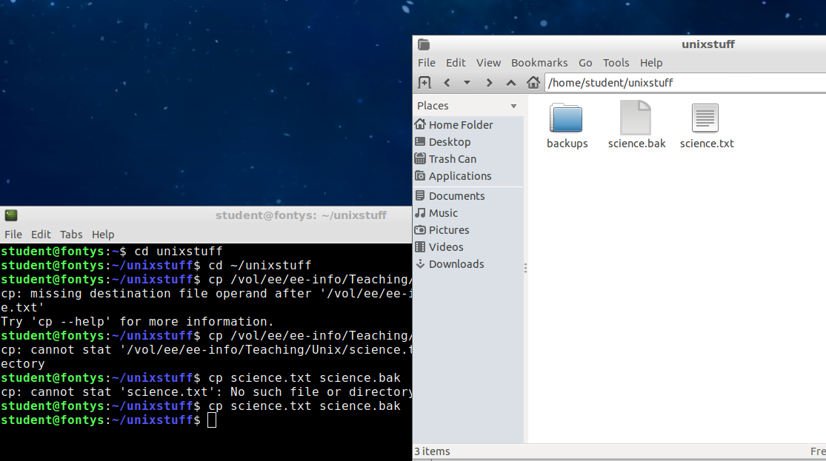

2.2

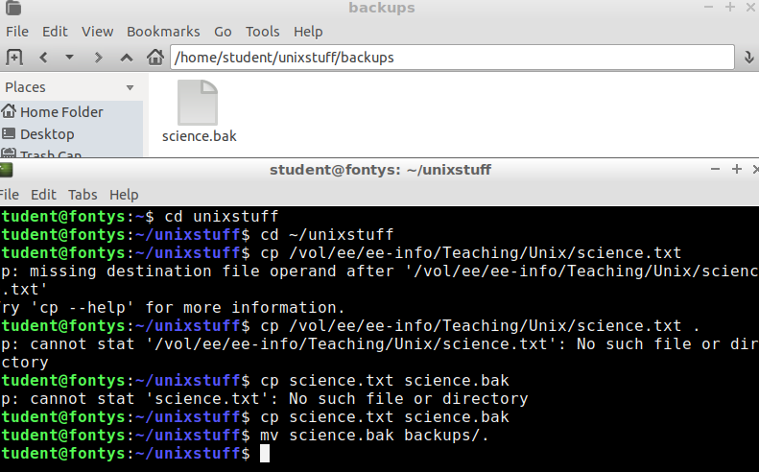

2.3

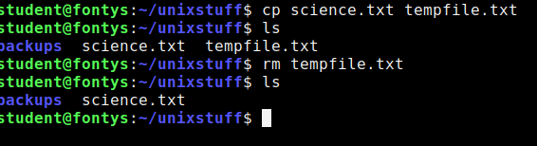

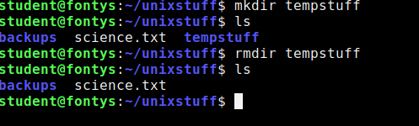

2.4

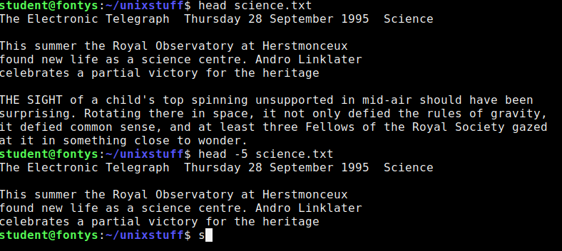

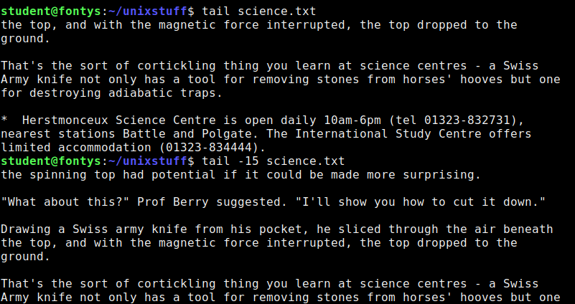

Task 2: Conversion Between Different Numeric Systems

Do not use Internet tools for the following conversions. We will question you how to do this without any tools.

Convert the following numbers from decimal to binary and show how you calculated it:

0 0 0 0 0 0 0 0

128 64 32 16 8 4 2 1

114 🡪 01110010

64+32+16 +2= 114

129 🡪 10000001

128+1 = 129

191 🡪 10111111

128+32+16+8+4+2+1 = 191

102 🡪 01100110

64+32+4+2 = 102

248 🡪 11111000

128+64+32+16+8 = 248

221 🡪 11011101

128+64+16+8+4+1 = 221

Convert the following numbers from decimal to hexadecimal and show how you calculated it:

0 1 2 3 4 5 6 7 8 9 10 11 12 13 14 15

0 1 2 3 4 5 6 7 8 9 A B C D E F

14 = E

E = 14

129= 81

129 / 16 = 8 restwaarde 1

8/16 = 0 restwaarde 0

191 = BF

191/16 = 11 restwaarde 15

11/16 = 0 restwaarde 11

102 = 66

102/16 = 6 restwaarde is 6

6/16 = 0 restwaarde is 6

248 = F8

248/16 = 15 restwaarde is 8

15/16 = 0 restwaarde is 15

221 = DD

221/16 = 13 restwaarde is 13

13/16 = 0 restwaarde is 13

Convert the following numbers from hexadecimal to binary and show how you calculated it:

FF

Fx16^1 + Fx16^0

15\*16 + 15\*1 = 255

255 🡪 11111111

128+63+32+16+8+4+2+1 = 255

F8

Fx16^1 + 8x16^0

15\*16 + 8\*1 = 248

248 🡪 11111000

128+64+32+16+8 = 248

ED

Ex16^1 + Dx16^0

14\*16 + 11\*1 = 237

237 🡪11101101

128+64+32+8+4+1

A5

Ax16^1 + 5x15^0

10\*16 + 5\*1 = 165

165🡪10100101  
128+32+4+1x

5A

5x16^1 + Ax16^0

5\*16 + 10\*1 = 90

90 🡪01011010

64+16+8+2

55

5x16^1 + 5x16 ^0

5\*16 + 5\*1 = 85

85 🡪01010101

64+16+4+1

AA

Ax16^1 + Ax16^0

10\*16 + 10\*1 = 170

170🡪10101010

128+32+8+2

12

1x16^1 + 2x16^0

1\*16 + 2\*1 = 18

18 🡪00010010

16+2

36

3x16^1 + 6x16^0

3\*16 + 6\*1 = 54

54 🡪00110110

32+16+4+2

48

4x16^1 + 8x16^0

4\*16 + 8\*1 = 72

72🡪01001000

64+8 = 72

Task 3: IP Address Conversions

Convert the following IP addresses to base 2 notations:

192.168.0.1 🡪 11000000.10101000.00000000.00000001

223.255.255.255 🡪 11011111.11111111.11111111.11111111

172.16.0.1 🡪 10101100.00010000.00000000.00000001

0.0.0.7 🡪 00000000.00000000.00000000.00000111

10.3.251.129 🡪 00001010.00000011.11111011.10000001

What would the above IP addresses look like when you represent the value of each byte into base 16 (hexadecimal) notations?

C0.A8.0.1

DF.E1.E1.E1

AC.A.0.1

0.0.0.7

A.3.FB.81

Task 4: IP addresses, subnets, masks, broadcast addresses

Calculate for each of the following IP addresses its subnet mask in dotted notation, its network address, the number of the nodes supported by this network and the host id of this IP address:

192.168.0.1/24

Subnet mask: 11111111. 11111111. 11111111.00000000 / 255.255.255.0

Network address: 192.168.0

Number of nodes: 2^8 -2 = 254

Host id: 1

122.233.128.5/16

Subnet mask: 11111111. 11111111.00000000.00000000 / 255.255.0.0

Network address: 122.233.128

Number of nodes: 2^16-2 = 65,534

Host id: 128.5

10.0.0.1/8

Subnet mask: 11111111.00000000.00000000.00000000 / 255.0.0.0

Network address: 10.0.0

Number of nodes: 2^24 – 2 = 16,777,214

Host id: 0.0.1

145.24.164.2/20

Subnet mask: 11111111. 11111111.11110000.00000000 / 255.255.240.0

Network address: 145.24.164

Number of nodes: 2^12 -2 = 4,094

Host id: 64.2

Task 5: Build A Simple Netkit Network

Read the explanation of the basic Netkit commands and use them to build a simple network of two nodes connected to a LAN network.

*Note : LAN network is being called collision domain in Netkit*

Try the following configurations:

A)

Configure IP addresses of the 2 nodes by using the “ifconfig” command explained in the theory lesson.

1. Node1 has an IP address 102.10.2.1/24
2. Node2 has an IP address 102.20.2.1/24

Check whether your 2 nodes can reach each other by using ICMP ping command between these two nodes.

1. What is the result of the ping? Can you explain it? Provide a screenshot.

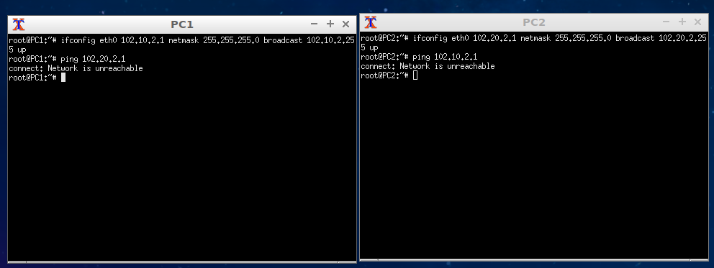

Ik krijg network is unreachable. Dit omdat het verschilende netwerken zijn.

2. Look at the ARP entries of your Node1 and Node2.

Which command do you use? Which ARP entries are there?

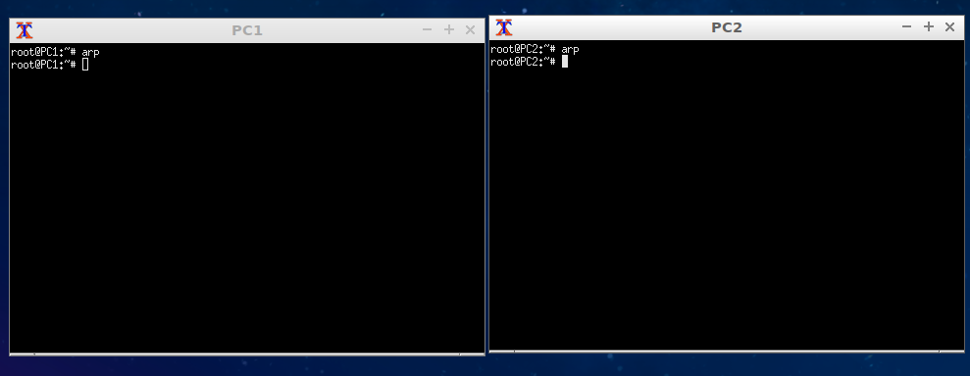

Ik gebruik het arp commando. Zit zou een lijst met arp cache entries moeten laten zien, maar die zijn er niet.

B)

Configure IP addresses of the 2 nodes in such a way that their subnet mask is 255.255.255.0 and the ping between them is successful.

1. Provide a screenshot of your configuration and successful ping.

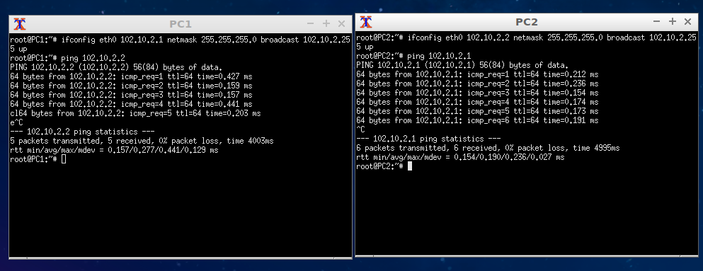

2. After successful ping ARP entries of both nodes should be changed. Provide a screenshot of the new ARP situation and explain it. What is the command to clear the ARP cache?

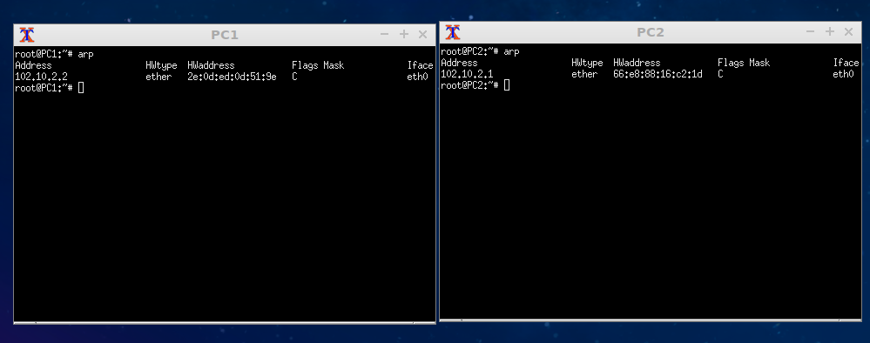

Task 6: Fill In Canvas Quiz Week 2

Task 7 (Optional): Subnetting Game

Go to the following page : <https://www.subnetting.net/Start.aspx>

and do the subnetting game. You should achieve at least 5 correct answers within the given time (5 minutes). You are allowed to skip some questions. It doesn’t matter how many wrong answers you have if you can achieve at least 5 correct answers. Of course, higher scores and less incorrect answers are appreciated.

Tip : use paper and some table like this:

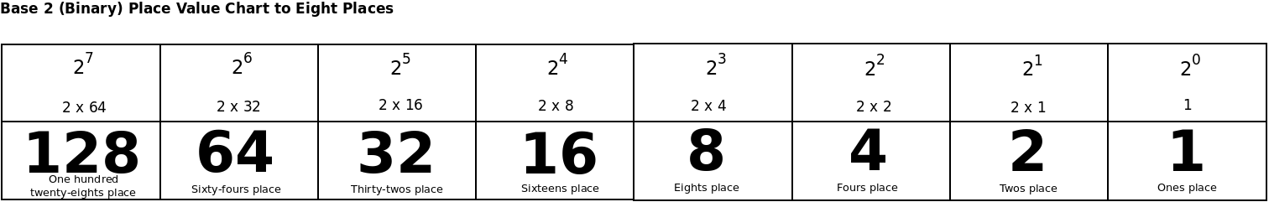

As a proof of achieving above described goal provide a screenshot from the result page of the game from which is to be seen that you achieved at least 5 correct answers.